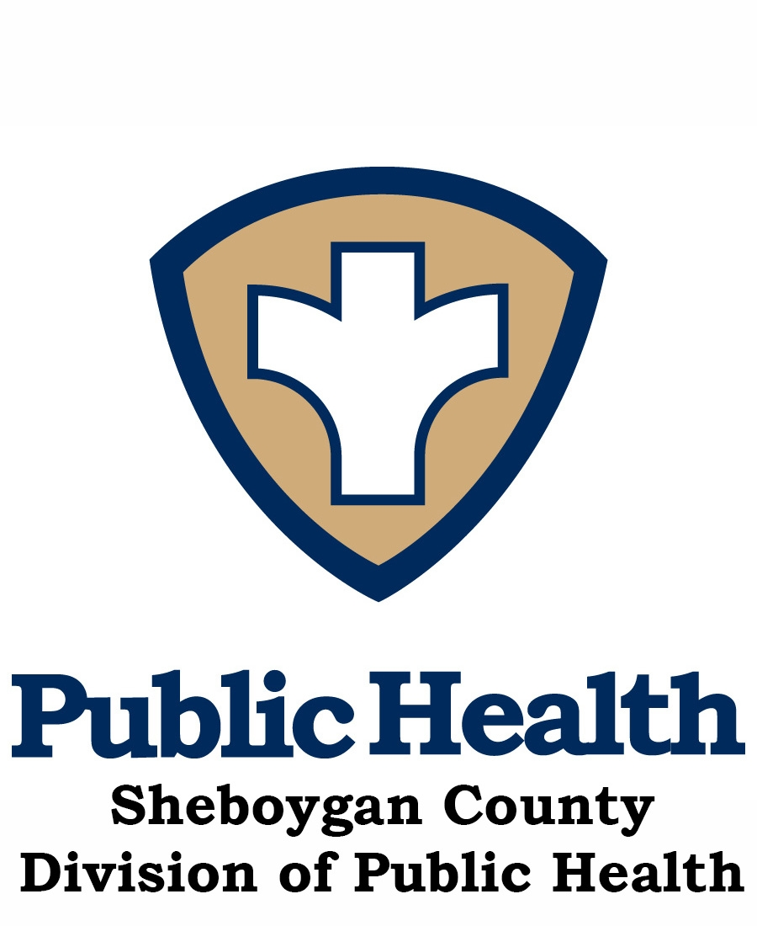

Sheboygan County Activity and Nutrition Coalition (SCAN)

MEETING MINUTES – August 22, 2017
DATE/TIME/PLACE |  |  | August 22, 2017, 8:05– 9:35 a.m. @ the Sheboygan County Food Bank: 3115 N. 21st Street, Sheboygan | PRESENT | Libby Holte, Mary Paluchiniak, Jenny Vorpagel, Liz Kroll, Judi Smith, Patrick Boyle, Darcy Vollrath, Joni Thoresen, Lauren Smith, Laura Apfellbech, Amanda Miller, Rachel Lewinski, Michelle Urbanek
PRESIDING | Amy Betke and Jean Pittner, Co-chairs
RECORDER |  | Jenny Vorpagel |  | EXCUSED |  | Kris F., Jeri D.
Mission Statement: The Sheboygan County Activity and Nutrition Coalition (SCAN) mission is to reduce the incidence of obesity and improve the health of children, families, and communities through education and promotion of healthy food choices, nutrition and increased physical activity.
Committee Goals:
- To promote healthy lifestyles for all age groups.
- Serve as a community resource to increase community exposure/education for local events and via the HSC2020 Website.
- Promote and encourage increased participation in the Employee Health & Fitness Day.
- Work to attain Sheboygan Well County designation in conjunction with the Wellness Council of Wisconsin.
AGENDA/TOPIC | DESCRIPTION/DISCUSSION/RECOMMENDATIONS | ACTION/FOLLOW-UP
INTRODUCTIONS/  Announcements  (Amy/Jean) | - Two new members: Rachel Lewinski (Fitness/Sports Core) and Janelle Schirmer RDN from Prevea/HSHS St. Nicholas Hospital.  - Kevin Donnelly has taken a new position as the Manager of the Sports Core as of 7.10.17. Will continue involvement with the Well County initiative, however may take a hiatus as from SCAN in order to become acquainted with his new role. Congratulations to Kevin!  - Amanda Miller will now be representing Sheboygan County for FoodWIse. Welcome Amanda! | Informational
PAST MINUTES | - Any Changes to the 5/16/17 and 6/20/17 Meeting Minutes? | No Changes
Liz Kroll and Lauren Smith | - Tour of the Sheboygan County Food Bank—Been in Sheboygan for 35 years. They have been at this location for 1.5 years. They work with 11 local food pantries throughout the county. There is an online ordering process for the pantries, and it is all free. They focus on health food instead of nutrient empty foods. They are attempting to change the culture of what foods people donate.  - Stock Box is a supplemental food program funded by the government for seniors 60 and older who qualify with a certain income. There are currently 7 county sites.  - They are a 501c3 with no funding from the government. All funding is from corporate and individual donations and grants.  - Liz has gone to all the pantries and done a needs assessment.  - Laura requested food drive posters in Spanish and Hmong for Manitowoc County and will be sharing it with us. | Informational  Laura to share posters in other launguages.
Review of progress of Community Health Assessment (CHA) and Community Health Improvement Plan (CHIP)  (Libby) | - Leadership Council Report: last meeting held July 24, 2017 (Libby)  - SCAN HSC 2020 Goals/Coalition: (Libby)  - CHA/CHIP update: (Libby)  The assessment was completed in May and now they are working on the CHIP. The Leadership Council have decided on what priorities HSC2020 will be focusing on, which still includes activity and nutrition. The Call to Action is scheduled for September 28th, and invitations have already been sent out. They are making sure this time that they have the capacity to achieve the priorities. After the call to action, they need to write the 2018-2020 health improvement plan. The other priorities for HSC2020 include: mental health, AODA issues, overall access (healthcare, insurance, etc), and target populations for each of those priorities, and looking at shared and baseline measurements. | Informational
HSC 2020 Website Update (Jenny) | - Updates: Remember to submit your events on the HSC202 website. The website may be changing with the new Community Health Assessment, however that would not happen until 2018. | Informational
HSC 2020 Press Articles (2017)  (Jenny) | - Updates: SCAN Member Articles!  - May 31st: Sheboygan Area School District Offers Free Summer Meals – Amy Giffin  - May 17th: Celebrate National Senior Health and Fitness Day – Kerri Robertson  - May 24th: Tips for Keeping Lawns Healthy for Everyone – Jonathan Ribich/Nourish  - June 7th: 6 Reasons to Shop at Your Local Farmer’s Markets – Beth Teunissen/RDN Sheboygan County Health and Human Services.  - June 14th: Practice Beach Safety this Summer in Sheboygan – Libby Holte  - June 28th: How Seniors can Keep Active While Staying Safe this Summer – Erica Gollhardt  - July 12th: Host a Healthy Summer Food Drive – Lauren Smith  - July 19th: Healthy Diet can be First Step to Building Resiliency in Life.  - August 2nd: Physical Health is Important for People of all Ages – Erica Gollhardt | Informational
Well County Designation Update – (Kelly/Kevin/Amy) | - Process Update: report from last subcommittee meeting Aug. 1, 2017  - Next Training event, Worksite Wellness Connection scheduled for Sept. 20th, 3:00-5:00 p.m. at the Inn on Woodlake.  - Also planning a December event. | Informational  Contact Amy or Kelly if you are interested in Well County.
Evergreen/Jaycee Quarry Trail Map (Initially Phillip Mercier UW Medical Student project/Jon Holcomb) (Jon) | - Updates: No updates at this time | Tabled  Jean to get in contact with Jon for October meeting.
Sheboygan County Food Bank Update  (Liz/Lauren) | - Updates: Lauren passed out information cards for the Making Spirits Bright 5k run and 1 mile walk on November 18th. They are looking for volunteers and sponsors. It is a family event and you can see Making Spirits Bright before it opens to the public! | Informational
Sheboygan Area School District update  (Judy, Amy G., Lisa)  Head Start – (Joni) | - Update: Installed 2 dishwashers and now have 4 in total. $40,000 grant for a serving line at Longfellow and walk in freezer at Farnsworth. 3 new additional dishwashers to be installed in the next year. Universal free breakfast was started at many schools this summer.  - Harvest of the Month: No updates  - PEP grant update: 2 more grade levels Jon is doing this year. They are pushing forward to fill a community educator position for the school district.  - Head Start—Getting ready for the school year and working on nutrition screening. Growth assessments on each child by the 45th school day. | Informational
Nourish Updates  (Ryan) | - Updates: No Updates
Senior Population Update (Darcy/Erica/Kerri) | - Updates: Erica is out on Maternity leave until 9.18.17 Walk with Ease class beginning Sept. 11th for six weeks and taught by Darcy. | Informational
Employee Health & Fitness Day (Sherri/Christine O.) | - Updates: No Updates
DYB Farmers’ Mkt. program and Small Steps Program -Donation for FM Mkt.  (Mary/Jean/Amy/  Maria/ Laura A.)  FoodWIse (Laura A.) | - Update: Significant increases this year because of the amount of times people can use them.  - Small Steps—50 $5 vouchers from United Way. They also gave $5 vouchers to WIC.  - FoodWIse –Univ. of WI – Extension Update: Amanda will now be the representative for Sheboygan County instead of Laura | Informational
North/South HS partnership and Walk/bike to school event  (Kevin/Mary) | - Update re: partnership with South and North High Schools – revisit for fall semester.  - Thank you note received from Chef Cathy Newport of Sheboygan South HS.  - Walk/Bike to School initiative tabled until May 2018. | Informational
Plymouth Wellness Initiatives  (Anne) | - Update: Carrie resigned from her postion as Nutrition and Wellness Coordinator position – as she and her family have relocated to Oregon. They have posted Carrie’s position, a full time wellness director. Getting ready for back to school, laying the groundwork for the WELCOA process. | Informational
City Planning Grant Initiative  (Nancy or Chad) | - Update: Market Fresh Meals on WSCS (collaboration of The City of Sheboygan Dept. of City Development/SCIO/Aurora) - Nancy Maring/Maria Liesegang/Michelle Urbanek. Maria comes up with a recipe and they look for market fresh ingredients. It is filmed at Relish, a downtown Sheboygan cooking store. Michelle is the host, and they just completed episode 4. Recipe and videos are on SCIO website. | Informational
Local Food System Project (Liz/Judy/Mary) | - Update: Tabled | Tabled
Reminder:  Dates and Minute Recorders for 2017 | 2017 Dates & Minutes Recorder:  September Canceled  October 17 Amy Giffin  November 21 Christine Oleksy  SCAN Mtg Cancelation Policy: if the Sheboygan Schools are closed d/t weather, we will NOT hold SCAN meetings. | Let Amy or Jean know if can’t take minutes or try to switch dates with someone.
NEW BUSINESS
NEXT MEETING | Next meeting date: October 17, 2017 8:05 – 9:35 a.m. @ the Health and Human Services Building Room 372. Amy Giffin will be the minutes Recorder.

