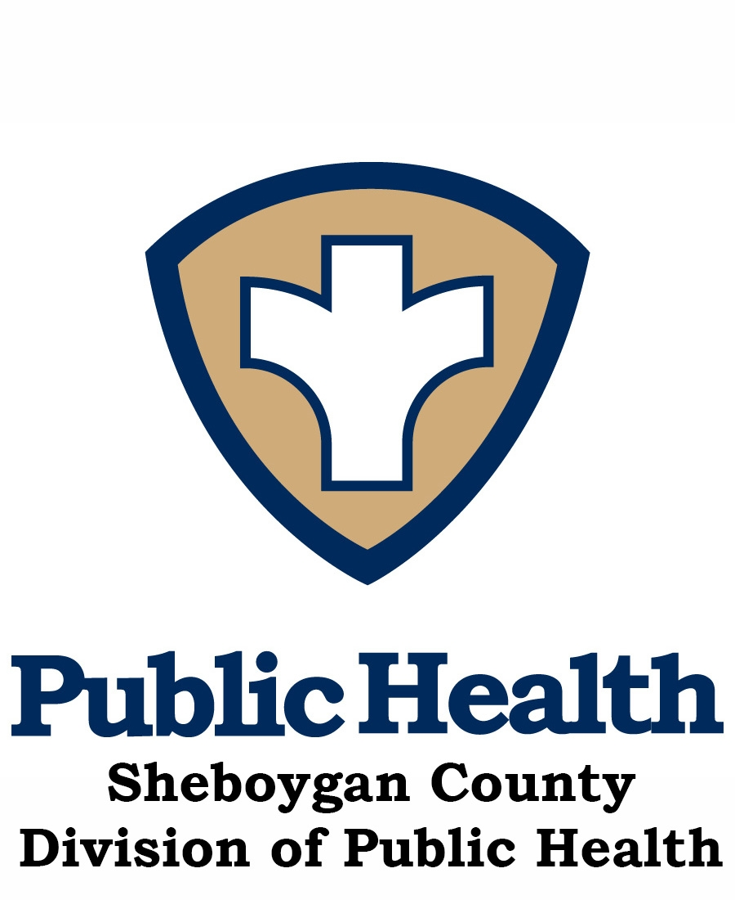

Sheboygan County Activity and Nutrition Coalition (SCAN)

MEETING Minutes – February 21, 2017
DATE/TIME/PLACE |  |  | February 21st, 2017, 8:05– 9:35 a.m.  Sheboygan County Health & Human Services Building Room 372 | PRESENT | Christa, Kevin, Erica, Darcy, Amy C., Christine, Nancy, Judi, Ryan, Megen, Joni, Jenny, Libby, Lauren, Mary, Anne, Michelle, Diane, Jean, Amy B.
PRESIDING | Amy Betke and Jean Pittner, Co-chairs
RECORDER |  | Lauren Smith |  | EXCUSED |  | Carolyn, Jeri, Kelly, Kerri, Chad, Sherri, Taylor, Kris
Mission Statement: The Sheboygan County Activity and Nutrition Coalition (SCAN) mission is to reduce the incidence of obesity and improve the health of children, families, and communities through education and promotion of healthy food choices, nutrition and increased physical activity.
Committee Goals:
- To promote healthy lifestyles for all age groups.
- Serve as a community resource to increase community exposure/education for local events and via the HSC2020 Website.
- Promote and encourage increased participation in the Employee Health & Fitness Day.
- Work to attain Sheboygan Well County designation in conjunction with the Wellness Council of Wisconsin.
AGENDA/TOPIC | DESCRIPTION/DISCUSSION/RECOMMENDATIONS | ACTION/FOLLOW-UP
INTRODUCTIONS  (Amy/Jean) | Introductions:  Anne Gamoke - Director of Student Services, Plymouth School District  Christa Wilson - PharmD Intern at Health and Human Services  Amy Catanzaro – UW-Oshkosh student with UW-Extension FoodWIse program  Nancy Maring – Sheboygan City Planning and Devleopment
PAST MINUTES | - No changes to the 1.17.2017 Meeting Minutes | Approved
Review of progress of Community Health Assessment (CHA) and Community Health Improvement Plan (CHIP)  (Libby) | - Leadership Council Report: last meeting held–Jan. 23, 2017. (Libby)  - CHA – Community phone surveys are completed. 400 people participated in the surveys. Key informant interviews are still in progress and must be completed by March 1st. Last piece of data collection is secondary data from the community and will come from key informants (i.e. police reports, hospitals, etc.). A Call to Action to develop strategies will take place in September.  - CHIP –Leadership Council is working on how to effectively measure progress. Workshop dates planned to educate coalitions on the process for measuring and reporting progress. | Await official September date for a Call to Action.
HSC 2020 Website Update (Jenny) | - Employee Health & Fitness Day information is available on the HSC2020 website, under SCAN. Jenny is also working on updates to the SCAN Well County page. SCIO Winter Farmers Market time/locations are available is up under “Events”. | If you have any upcoming events, submit them to Jenny using the “online event submission form” under “Events”.
HSC 2020 Press Articles  (Jenny) | - All but one article slot is filled up through May. Openings for the rest of the year will be made available on a future meeting date. | Informational
Well County Designation Update – (Amy) | - Process Update: report from last subcommittee meeting February 7, 2017.  - Rescheduled January 25th Initial Sheboygan Well County Particpant Training to Feb. 22, 2017, due to weather.  - Feb 22nd will be the first group session/Trainig and Mentoring two hour meeting for Companies signed on for Well County. There are ~ 23-26 participants signed up for this meeting to take place at Sargento hosted by WELCOA.  - On Wednesday April 19th WELCOA University will be held at Sargento. This all day event will walk participants through the benchmarks for the Well County process. | Informational  Contact Amy, Jean, or Kelly if you would like more information.
Evergreen/Jaycee Quarry Trail Map (Initially Phillip Mercier UW Medical Student project/Jon Holcomb) (Jon) | - Jon was not able to attend today’s meeting, no update. | Tabled
Local Food System Project and Sheboygan County Food Bank Update  (Liz) | - Local Food System Project: Judy and Heather (Nourish) created an online survey for the Lakeshore Local Food Network (LLFN). They have sent out a survey to coordinate future meetings.  - Sheboygan County Food Bank: Liz was not able to attend today’s meeting, no update. | Await updates on future meetings.  Tabled
Sheboygan Area School District update  (Judy or Amy G.)  Head Start – (Joni) | - February Harvest of the Month (HOM) – Amy G. is continuing to work on the HOM with Nourish and Plymouth educator, Karrie.  - Remodeling of South High kitchen will be finished soon. The elementary school food for the six south side sites is now being prepared at South. The North High remodel is still in progress.  - Schools will have new kitchens equipped with dishwashers. There will be a total of five dishwashers in the district when the referendum is done. This will promote the use of reusable dishes and work towards the long term goal to be more environemtnally friendly.  - PEP grant update: SASD Nutrition and Nourish are starting the MyPlate curriculum for teachers as well as the pre-assessment that will measure where the kids are in the spectrum of nutrition.  - An Article written by member Kris Fritz, that was publish in PHE America (Physical &Health Education America), entitled 50 Million Strong by 2029, was shared with the group, and posted on the Sheboygan County Public Health Facebook page. | Informational
Nourish Updates  (Ryan) | - Farm to Table tours – Offered for education to all businesses; tweaking programs like this to incorporate smaller businesses as well, that do not have wellness coordinators.  - Harvest of the Month – Distributing flyers to Carrie in Plymouth as well as Sheboygan schools that Nourish is already involved with. All of Nourish’s snacks now align with the nutrition education materials. Focusing on making Nutrition education easier to be integrated by teachers in classrooms.  - Community Dinners – Almost sold out for the last dinner. A variety of people with different backgrounds attended, including professionals, educators, and people with little food knowledge.  - Midwest Organic Sustainable Education Service (MOSES) – Ryan will be attending the 2017 conference with Jake L. from Nourish. MOSES is one of the top organic growing conferences in the U.S. and is conveniently locted in Wisconsin.  - There will be a total of four events targeting seniors this year. Nourish is collaborating with the Senior Activity Center for these events. | Informational
Senior Population Update (Darcy/Erica/Kerri) | - Update: Beginning a Live and Learn series that focuses on mental health. Topics include “How to Grow Old”, “Prepare for a Funeral”, etc.  - Senior Health and Fitness Day will be Saturday, June 3rd to align with the opening of Farmers Market. Erica is trying to coordinate this to include the Plymouth JV dance team to dance with seniors to promote interactions between seniors and high school students.  - Kerri will be going to Stepping On training next week for Falls Prevention. | Informational
Employee Health & Fitness Day (Sherri/Christine O.) | - Updates: Employee Health & Fitness Day will be Wednesday, May 17th. Green, yellow graphic on a grey t-shirts won the popular vote! Christine O. has t-shirts, regirstration, and other information ready for participants | If you are interested, you can access registration and other information on th HSC 2020 website under SCAN.
Food Drive Toolkit & DYB Farmers’ Mkt. program  (Mary/Jean/Amy/ Liz, Laura A.) | - Update: re: finalization – Working on last few edits.  - There are still substantial funds left over from 2106. Looking to expand DYB dates from two times per month and reducing administrative fees by increasing volunteer staff. Mary will be meeting with Heidi from SCIO tomorrow to discuss the use of excess funds and the future of DYB. Also considering a similar DYB concept for WIC clients who currently only receive $20.00 per summer market season from the state. | Informational
Miler in Training 2016-2017  (Kevin/Mary/ Jean/Amy) | - Update re: partnership with South and North High Schools – Kevin reported that the Health & Fitness Course/program is going well.  - Rename project- Merge into PEP grant? No updates.  - Walk/Bike to School initiative: Jackson Elementary onboard to do program on May 9th. Trying to figure out a safe route; collaborating with the Sheboygan Police and Fire Departments. | Informational
Reminder:  Dates and Minute Recorders for 2017 | 2017 Dates & Minutes Recorder:  January 17th Lauren Smith  February 21 Liz Kroll  March 21 Megen Rapp  April 18 Michelle Urbanek  May 16 Ryan Laswell – Will be held at Nourish  June 20 Sherri Samuels-Fuerst  July ---------No Meeting ------------------  August 15 Taylor Haeffele  September 19 Vicky Schneider  October 17 Amy Giffin  November 21 Christine Oleksy
NEW BUSINESS
Well Workplace Award (Jeri) | - Gold Award Level achieved by SASD. | Congratulations to Jeri on all of her hard work.
Plymouth Wellness Initiatives (Carrie, Anne) | - The Plymouth School district has signed on to the Well County initiative. Their focus is to have staff be healthy role models for students.  - Alex (Personal Trainer) and Michelle provide wellness sessions for teachers. Mental Health America trainings are available to beter support the mental health needs of staff. | Informational
City Planning Grant Initiative  Nancy Maring | - Nancy, Sheboygan City Planning and Development reported on a five year UW Public Health grant with Sheboygan County. Next steps: meeting with organizers of the grant and other local reresentatives. Looking for ideas on how this grant could be used in our community/ways to make the community healthier (i.e. Partnership with other programs such as Fall Prevention, Demtia Friendly Communities, Healthy Eating, Community Activities, etc…) | Contact Nancy with any ideas or suggestions for grant project  nancy.maring@sheboyganwi.gov
SCAN Mtg Cancelation Policy | Consenseus of HSC 2020 Subcommittee’s - policy will be such that if the Sheboygan Schools are closed, we will NOT hold subcommittee meetings. | Informational
Roundtable: (All) | Lauren-The Sheboygan County Food Bank (SCFB) partners with Hunger Task Force (HTF) in Milwaukee to deliver monthly Stockboxes to low-income seniors in Sheboygan. HTF delivers boxes and SCFB distributes to apartments throughout the county. Their reach is 70 people and are working on serving 100+ by March with the addition of St. Nick Apartments. SCFB has an Instagram account with the same username as Twitter (ShebCtyFoodBank). Follow us!  Libby: April 29th is the medication take back date. Still looking for volunteers. Flyers anticipated in the next few weeks.  Michelle: Intern put together a document with nearby running and cycling races. See attached.  Joni: Dietitians are providing growth assessments/BMI for kids at Headstart. Data is sent home in folders for parents to view progress.  Megen Rapp: On March 4th there will be a 5K run in Kohler. Registration is $35. United Way of Sheboygan will be a beneficiary.  Ryan: Nourish now has five full-time staff and will have two paid interns this summer. Interns will focus on integrating academic, system, and farming aspects. The internship applications are not posted yet, but look for them to be available in the near future.  Judy: Amy is coordinating volunteers for summer to assist with food service over the lunch hours. Currently feeding over 1,000 children per day. Wilson location will be closing due to the remodel.  Jean/Amy: Completed 2016 SCAN Accomplishments Summary (Basic Overview of activities…highlights only). | Informational  Contact Libby if you are able to help.  Informational  Informational  Informational  Informational  If you are interested in volunteering, contact Judy or Amy G.
NEXT MEETING | Next meeting date: March 21, 2017 Room 372 Health and Human Services Building:  8:05 – 9:35 a.m. Megen Rapp will be the minutes Recorder.

