**REGISTER NOW! *Preregistration Required \***

**A Workshop for the Businesses of Sheboygan County**

***Building a Sheboygan Well County***

**Thursday April 28, 2016**

UW Sheboygan

Acuity Technology Center

Wombat Room

**7:30 – 8:00 AM (Registration)**

**8:00 –Noon (Presentation)**

**PROGRAM HIGHLIGHTS:**

* ***Free*** Presentation and Resources
* ***Breakfast*** *provided:* sponsored by Prevea Health & Aurora Health Care
* Network with other local businesses and their wellness programing

**TOPICS COVERED:**

* Legal updates re: Wellness Programs
* Break-Out Sessions:
  + Resilience in the Workplace
  + Workplace Environment & Wellness
  + How to Support Employees with Addiction
* Panel Discussion with representatives from area business of various sizes.
* What does it mean to be one of America’s Healthiest Companies?
* The Steps to Achieving WELCOA’s Well Workplace Award.

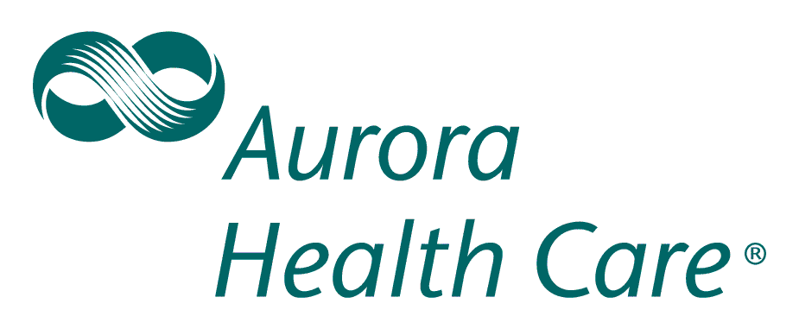**SPONSORED BY:**

  **Presenters:**

* **Cory Jorbin, JD**

**Compliance Officer, Central Region Employee Benefits HUB** **International Insurance Services Inc**

* Legalities of Wellness: Keeping Your Wellness Program Compliant
* An update on EEOC rulings as related to the three current WI cases
* Submitted for HRCI credits
* **Break-Out Sessions:** refer to Registration Form
* **Panel Discussion with Representatives from:**

**Masters Gallery Foods, Inc., Burkhardt Heisdorf and Sargento Foods Inc.**

* Worksite Wellness…What Works for our Employees?
* What have we learned? How do we promote? What is our vision for Wellness programing?
* **Jessica Raddemann**

**Executive Director Wellness Council WI**

* How does WELCOA’s coveted designation benefit your organization….Jessica will walk attendees thru the steps to achieving the award.









REGISTRATION FORM

**A Workshop for the Businesses of Sheboygan County**

***Building a Sheboygan Well County***

***Assist in building and guiding your businesses’ wellness programs and a Well County!***

**REGISTRATION DEADLINE: Friday April 22, 2016**

Program: Thursday April 28, 2016

UW Sheboygan Campus Acuity Technology Center Wombat Room

Registration and Breakfast – 7:30-8:00 a.m.

Program - 8:00 a.m. - Noon

Choose the **ONE** Break out Session you plan to attend:

Resilience in the Workplace: Learn why resilience is a critical workplace skill and how to nurture this competency within your employees.

**Kate Baer, BA, MS**  Executive Director Mental Health America Sheboygan

Workplace Environment and Wellness: Make the Healthy Choice the Easy Choice! **Kelly Boeldt,** **Partnership Services Coordinator for Prevea Health, Chairperson for Healthy Sheboygan County 2020 *Sheboygan Well County***

Your employee failed a drug test – fire’em or support their recovery? **MaryAdele Revoy**, **MS**

|  |  |  |  |  |  |  |  |  |
| --- | --- | --- | --- | --- | --- | --- | --- | --- |
| Name: |  | | | | | | | |
|  |  | |  |  | | |  |  |
| Organization Name: | | |  | | | | | |
|  |  | |  |  | | |  |  |
|  |  | |  |  | | |  |  |
| Street Address: | |  | | | | | | |
|  |  | |  | | |  |  |  |
| City: |  | | | | State: |  | Zip: |  |
|  |  | |  | | |  |  |  |
| Phone: |  | | | | | | | |
|  |  | |  |  | | |  |  |
| Email: |  | | | | | | | |

*Email will be used to confirm your registration and send future updates; in addition will share with speakers and/or attendees if requested.

**Please complete form and return to: Angela Lammers**

**Email:** [Hsc2020@sheboygancounty.com](mailto:Hsc2020@sheboygancounty.com)

**or fax** to 920-459-0529

**Contact with Questions:**

Amy Betke – 920-459-3036 – [Amy.Betke@Sheboygan](mailto:Amy.Betke@Sheboygan)County.com

Jean Pittner – 920-459-3219 – [Jean.Pittner@SheboyganCounty.com](mailto:Jean.Pittner@SheboyganCounty.com)