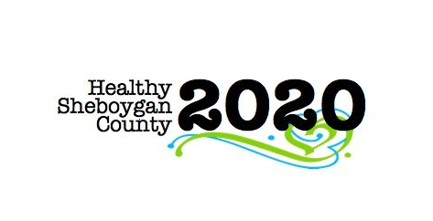
HSC 2020

SBIRT - Screening, Brief Intervention, and Referral to Treatment

Mental Health & Substance Abuse [MHSA] Community Health Committee

Minutes
DATE: | Wednesday, November 16th, 8:05-9:00am | LOCATION: | Department of Health and Human Services, Room 372
PRESIDING: | Shelby Kuhn; Kari Keller
PRESENT: | Kristin Stearns, Shelby Kuhn, Jenny Vorpagel, Amanda Anhalt, Mary Paluchniak, Ann Bachrach, Anne Gamoke, Sara Sandman, Susan Hein, Char Pachniak, Regan Haulotte, Kari Keller, Vicky Schneider
ABSENT/EXCUSED: | Libby Holte, Cindy Vander Weele
RECORDER: | Jenny Vorpagel
NEXT MEETING: | Wednesday, December 21st, 8:05am-9:00am

ITEM | DISCUSSION/CONCLUSION/RECOMMENDATIONS
Welcome and Introductions | Welcome new members!
Follow-up  - Clinic/Hospital Implementation  - SBIRT Training – Richard Brown  - SBIRT and the Schools | - Review survey data and feedback from events-Kari passed out and went over. Capt. Veeser is looking at using the Acuity money to fund trainings.  - Review progress of School/SBIRT initiative: ways that HSC2020 can help this effort succeed  - Barriers and solutions  - A small group met to discuss the school presentation and next steps:  - Discussion about if the trainer can come to our county and when the trainings will be.  - There is a school sub-meeting in January. Date still TBD.  - Are Lutheran and Christian high being included?  - Discussion about how there may be fewer referrals because of the brief intervention piece of SBIRT. The goal is to prevent kids to go to specialty care that don’t actually need it.  - Shelby described past discussion about “pinch hitters” like MHA. Also providers going to kids instead of kids and parents coming to them.  - Kari will make sure some of the people present receive school PowerPoint presentation.  - Review of status with Healthcare/SBIRT initiative  - Barriers and solutions  - Aurora/Prevea efforts- status—Concerns about implementation. $50,000 for 12 people to be trained.  - Mary—did presentation on 11/15 and looking for pilot program  - Motivational interviewing training is essential  - Budgeting for a nurse to do SBIRT might be better than other alternatives.
Change Maker Grant/UW Madison Wisconsin Partnership Program | - Medical College of Wisconsin Changemaker grant  - http://www.med.wisc.edu/wisconsin-partnership-program/community-opportunity-grants-program/44947  - We meet all the objectives, this may be more feasible now rather than the change maker grant. Shelby will reach out to get more information on whether we can apply for this.  - UW-Madison mentoring grant—supports planning and prep of project, $25,000  - Timelines for 2017? Deadlines will be early in the year- February?
Report Out on Action Steps from Previous Meeting
Report Out for Full Committee
- Summary
- Barriers
- Celebrations
- Asks
Don’t forget these items as part of action plan:  Education/Prevention  Access to Service  Coordination/Continuity of Care  Health Literacy | Review the CHIP goals and objectives—Shelby went over CHIP objectives and how we’re progressing.
Other- Brief round table and updates on organizations/community events.

