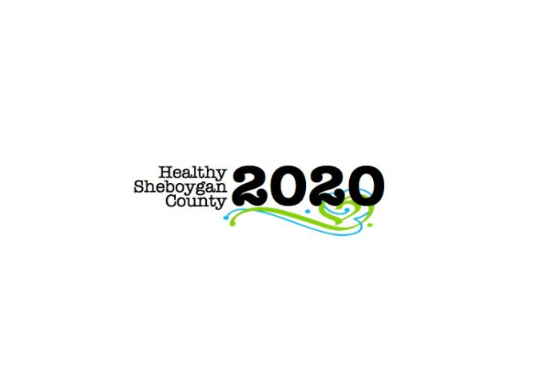
HSC 2020 Mental Health Substance Abuse Community Health Committee

Stigma
Thursday July 6th, 2017
Minutes

DATE: | Thursday July 6th, 2017 8:05am-9am | LOCATION: | Sheboygan Dept. of Health & Human Services, Rm. 372
PRESIDING: | Libby Holte
PRESENT: | Libby Holte, Connie Bitter, Pam Krueger, Mary Paluchniak, Shelby Kuhn, Pastor Mark Janzen, Jenny Vorpagel, Miva Yang
ABSENT/EXCUSED: | Kate Baer, Barb Kolar
GUESTS: | Erica Rex (UW Oshkosh Student), Nate Davis (AHEC intern), Sam Kefer (AHEC intern)
RECORDER: | Jenny Vorpagel
NEXT MEETING: | August 3rd—Place TBD

ITEM | DISCUSSION/CONCLUSION/RECOMMENDATIONS
Welcome and Brief Introductions | Libby briefly went over the new CHIP that is in progress.
QPR Plan  - Target Populations to Train  - Goals  - How to measure outcomes | Question, Persuade, Refer  June 16th there was a QPR training, about 18 people in the community attended. These people are now trainers. The group brainstormed about target populations and how to reach them:  The group of QPR trainers are meeting next week.
Ideas to Pursue for 2018
Roundtable

