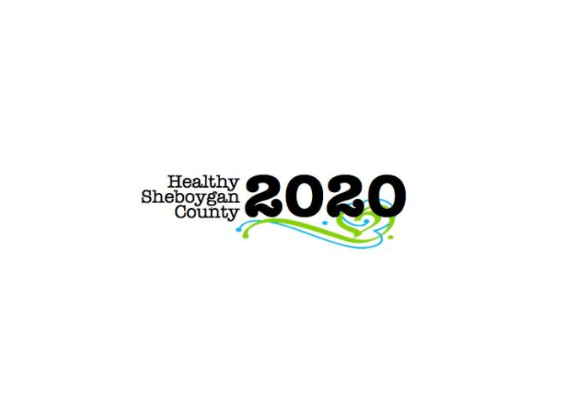
HSC 2020 Mental Health Substance Abuse Community Health Committee

Stigma
Thursday May 4th, 2017
Minutes

DATE: | Thursday May 4th, 2017 8:05am-9am | LOCATION: | Sheboygan Dept. of Health & Human Services, Rm. 372
PRESIDING: | Kate Baer, Libby Holte
PRESENT: | Barb Kolar, Shelby Kuhn, Libby Holte, Ann Bachrach, Mary Paluchniak, Connie Frank, Pamela Krueger, Connie Bitter, Kate Baer, Jenny Vorpagel
ABSENT/EXCUSED: | Miva Yang
GUESTS:
RECORDER: | Jenny Vorpagel
NEXT MEETING: | June 1st, 2017 (8:05am)

ITEM | DISCUSSION/CONCLUSION/RECOMMENDATIONS
Welcome and Brief Introductions | Congrats to Ann for being identified as a women leader in Sheboygan County by the Chamber!
2017 Mental Health & AODA  Resource Fair Follow Up Conversation | The event went well, and Jess did a wonderful job. There was a lot of leftover pizza. Numbers were down, about 100 people attended. Discussion took place whether to do the fair every other year. The directory comes out every two years; we could only do the fair the years the directory comes out. Additional discussion took place about what could be improved at future events.  If there are any more comments or feedback, please let Mary P know.
Directory of Community Resources Ask/Support Needed | Libby spoke to someone who didn’t know the directory existed. She will work with Kate to get him a box of books.
Question, Persuade, & Refer (QPR) Suicide Prevention Goal for 2017 - Timeline and Implementation Discussion | Kate just received the contract. It cost is $495/person unless we have 10 people then it is $395/person. They have June 16th available. Instructor travel is $350 and shipping materials is $280. The estimated count of students is June 2nd.  Group discussed the QPR seminar at the suicide prevention conference, and concerns about how much Wisconsin QPR trainings are being altered.  Public Health can send 2-4 people, MHA will send one. Kate will see if she can attend to assist, and not as one of the students.  Next Steps: Small group will set up a meeting next week for targeted invitations. Invitations should be sent out by May 15th.
Thinking Ahead – Outcome measurements, 2018 ideas & discussion

Roundtable & Follow Up Action Check Out

