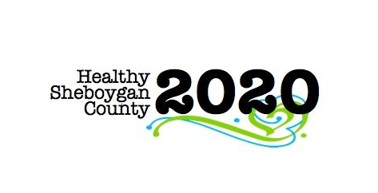
HSC 2020

SBIRT - Screening, Brief Intervention, and Referral to Treatment

Mental Health & Substance Abuse [MHSA] Community Health Committee

Minutes
DATE: | September 20, 2017 at 8:05AM | LOCATION: | Room 372
PRESIDING: | Shelby Kuhn and Kari Keller
PRESENT: | Cindy VanderWeele, Char Pachniak, Shelby Kuhn, Kari Keller, Mary Paluchniak, Trisha Erpelding, Connie Frank, Kate Baer, Sara Sandman, Libby Holte, Jenny Vorpagel
ABSENT/EXCUSED:
GUESTS: | Karly Daul (Nursing Student)
RECORDER: | Jenny Vorpagel
NEXT MEETING: | October 18, 2017

ITEM | DISCUSSION/CONCLUSION/RECOMMENDATIONS
Kari and Shelby will report on the two school SBIRT Trainings that were held in August 2017.  How will we gather outcomes on the school SBIRT work? | School trainings went well. Discussion about the trainings took place. There could have been more time for teams to discuss things together.  Kari reported they are working on scheduling a date in December to meet with Scott again to see how things are going.
Cindy will report on the Provider Summit that was held in July and upcoming 10-27-17 School-Provider Meeting. Shelby, Cindy and Kari can report on their progress on action steps from 8/22/17 conference call. | Cindy passed around a list of providers that have been invited to meet in October. The group discussed who will attempt to contact people who have not responded to the invitation. The group decided the MOU should be done and signed before the October meeting.  Discussion of whether to include Lutheran Social Services. They are very willing to go to the schools, but they are not counselors.
Libby will report on the Community Health Assessment process. | Libby went over the process of the Community Health Improvement Plan. There are 4 pieces, the community health survey, key informant interviews, secondary data, and a priority issues survey for more community input. All of those are completed. Now they are in the process of creating the CHIP. The Call to Action is on September 28th at Acuity. In the past we have focused more on the “what” rather than the “how”. This year, the priority issues have already been determined for the Call to Action. That day will be focused more on the “how”. Priorities are: Obesity/Nutrition, AODA, Mental Health, and Access to Services. There are 3 objectives for the day: How we got to those priorities, what are our goals for each priority, and to get a commitment from attendees.  Once we find out from the systems, we will set strategies, which will be a “call to action part 2”. Those meetings will happen at the end of October and beginning of November and anyone is invited to the meetings. Once all the meetings are over, the CHIP will be written and completed by the end of March.  Leadership council has been working on how to better support the committees and sub-committees.

