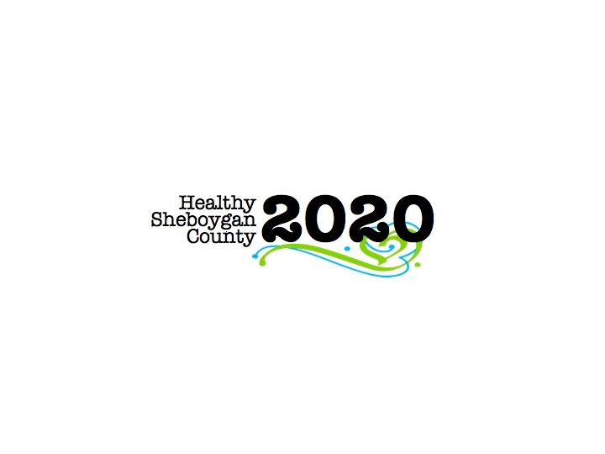
HSC 2020 Mental Health & Substance Abuse [MHSA]

Community Health Committee

HEROIN SUB-COMMITTEE MINUTES
DATE: | Wednesday, September 14th; 3:00pm-4:30pm | LOCATION: | Sheboygan Dept. of Health & Human Services Room 372
PRESIDING: | Libby Holte and Kurt Zempel
PRESENT: | Libby Holte, Kurt Zempel, Lindsay Rick, Jenny Vorpagel, Mary Paluchniak, Liz Abler, Jack Pawley, Katie Phillips, Mary Karls, Ellen Wells, Jenny Lawrence, Sue Thiel, Todd Priebe, Liz Campion, Stephanie Preder, George B, Jean Biegun, Robert Ingraham, Annette Selk
ABSENT:
RECORDER: | Jenny Vorpagel
NEXT MEETING: | October 12th, 2016 3-4:30pm

PILLAR | TOPICS | DISCUSSION & DECISIONS  TAKE HOME TASKS
Welcome & Introductions | Recovery month calendar was created and sent out electronically. If you did not receive it through email, please let Libby know that you’d like a copy: HSC2020@sheboygancounty.com  Think Haus at JMKAC at 7pm- first of the season. Focus is how addiction can happen to anyone. Sheriff Priebe will be telling his own story.  Northshore clinic is doing a program for adolescents and parents for AODA. It Began 2 weeks ago.
PILLAR REPORTS:  Education/ Prevention Pillar | The pillar has been meeting with Plymouth to get something started to talk about addiction. Liz Abler applied for a $500 SAMSA grant. October 25th is “plan your future night” in Plymouth, representatives from the pillar will be there to do a parent-to-parent session, and student-to-student session.  4th Tuesday of each month is pillar meeting, from 1-2pm in room 218 in HHS building. The first meeting is 9/27  Deb and Libby are looking at schools—how can we better develop relationship with schools and where they are at. Outagamie Co suggested reaching out to CESA. Libby contacted CESA and they invited her to CESA networking meeting.  If you have any relationships with school contacts that could be brought to the table, let us know! Libby will send out an email with a list of all the pillar-meeting times for the next month.  St. Mark’s Lutheran church reached out to Libby. They are having a resource fair on 10/9 from 10-11:30am and invited HSC2020 to attend for drug drop off purposes. Would anyone like to represent HSC2020? Let Libby know.  Kurt has been doing presentations at different clubs (rotary, optimists, etc); we should begin tracking how many people we are reaching and where we are presenting. | Libby will send out an email with a list of all the pillar-meeting times for the next month.
Harm Reduction Pillar | Medication disposal take back day is 10/22 from 10am-1pm—The last one was in April, we had site leaders that were point people for all other volunteers, and it worked well. Can the same site leaders do this take back day? At the next meeting, all the materials will be given out and the sign-up sheet will be finalized. Marketing for this event will be in local papers in all county communities and on our website. The same 5 sites have been confirmed. Keep in mind that we also have our permanent sites. Not as many people in the community know about them as we previously thought. Mary is in contact with local pharmacist about stapling permanent take back sites to prescription drugs being taken out of pharmacies.  EpiPens can be disposed of at the Sheboygan PD box. It has been added to the half sheet permanent drug take back site literature.  Mary will have sharps containers at the take back day for all locations.  Sargento health fair this Saturday, Liz A will be doing a drug take back display and giving out half sheets.  The pillar is still working on needle exchange. There are 2 locations currently in the county. Determining if more locations are needed before we talk about making changes. The Pharmacy group is meeting at the end of September. Early 2016 that group may host a meeting between pharmacies and prescribers, determining how HSC2020 could contribute.  New person at Advanced Pain Management has been invited to meeting. Not present today.  If anyone has information about community sharps containers, please let this pillar know. Libby recently found out all Kwik Trip’s have sharps containers. We should contact Kwik Trip to see how they dispose of their sharps, are they local?  Robert--Wisconsin Recovery Foundation. The board of directors of what was the 1907 Club is now Wisconsin Recovery Foundation-Sheboygan. They would like to start phone recovery support and peer counseling training. They will also have table at the recovery rally this Saturday. Other counties in the state also have a Recovery Pillar. Discussion took place whether recovery is covered well enough in the treatment pillar. The group voted to start a new recovery pillar, Robert will be the chair of that pillar. | Robert to look into how the new pillar will be structured, and will report back at October meeting.
Treatment Pillar | Lindsay reported successful treatment provider networking event in August. 11 different facilities and 17 individuals were there. Participants requested quarterly networking event. Local providers received materials for recovery month.  Friday 11/4 another event is scheduled for networking. It is helping identify gaps in treatment in the county. Lindsay has heard about sober living opportunities in the community. Once they are set in stone she will let us know.
Law Enforcement Pillar | A webinar several people participated in talked about things that have worked in other communities RE heroin.  1) Prevention WORKS. When you can increase exposure with a consistent message, it does prevent people from the cycle of addiction/abuse.  2) Interventions save lives. Everything on their list we are working on or already doing. (Ex: SBIRT was brought up and we have a subcommittee on that)  3) safe drug disposal  4) DEA taskforces  5) NARCAN training  This pillar can consider police assisted referral and treatment. Good idea to begin promoting good Samaritan laws and EAP’s. Hazelton has toolkit for educational events.  When opiates are given at pharmacies, the patient should also be given safe disposal and storage information, along with recovery information.
Workplace Pillar | A survey was created by county interns and was tweaked by Pam, Jenny and Ellen. Jenny plans to send out survey to the pillar on Monday to get feedback by Friday, then it will be sent to the Chamber and they will send it out for the pillar to local businesses. Ellen has a list from Workforce Development. Once they receive feedback, they will work from there depending on the responses.  Great workplace resources that can be distributed to interested parties.  In October Kohler will host a North America region HR conference.  Workplace pillar can work with prevention pillar about the importance of employment during recovery.
Leadership Council Update | Community Health Needs Assessment is being worked on now and is done every 3 years. They are currently working on changing the heroin subcommittee to an overall AODA subcommittee. Right now, they are putting together data pieces (key informant interviews, secondary data, and surveys) and hope to have all data collected by the end of Spring 2017. Community engagement session will be held in September 2017 to talk about collected data. It is important to get community involvement.  Fiscal agent (currently Aurora foundation) is moving to “Project fiscal agents” Ex:—AODA resource fair is done by HSC2020 & MHA. They are the fiscal agent for that project. Other counties operate this way and it is a smoother process.  We are working on making a welcome packet for HSC2020 that will include information about each committee/subcommittee. It will be in an electronic format. It will be sent out to all members once it is finalized at the leadership meeting.
Next Steps | -Look at your pillar goals  -Who is not at the table that should be?  -Kurt and Libby are looking at what data other counties are collecting, and will come back with recommendations at next meeting.  -See Libby if you want to volunteer for take back day  -November 16th 9-10am is the next MHSA full committee meeting.  October 19th Dr. Brown SBIRT presentation. Let Jenny or Libby know if you would like to attend either session.  -9/29 HSC2020 will be present at Chamber event. Let Libby know if you want any materials shared.

