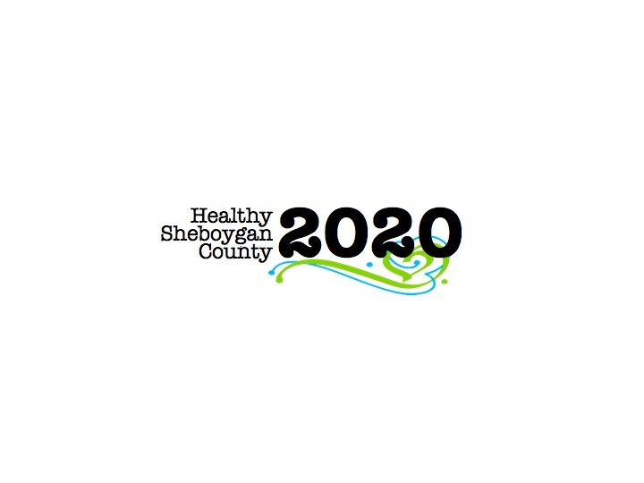
HSC 2020 Mental Health & Substance Abuse [MHSA]

Community Health Committee

HEROIN SUB-COMMITTEE MINUTES
DATE: | Wednesday, September 13th, 2017 3-4:30pm | LOCATION: | Sheboygan Dept. of Health & Human Services Room 372
PRESIDING: | Libby Holte
PRESENT: | Jenny Vorpagel, Vicky Schneider, John Nonweiler, Annette Selk, Pamela Krueger, Kelly Nonweiler, Stephanie Preder, Shelby Kuhn, Michael Stelter, Michelle Kleppin, Sue Thiel, Jamie Chesak, Liz Campion, Deb Schmidt, Mary Paluchniak, Libby Holte
ABSENT:
RECORDER: | Jenny Vorpagel
NEXT MEETING: | Wednesday, November 8th, 2017 3-4:30pm

PILLAR | TOPICS | DISCUSSION & DECISIONS  TAKE HOME TASKS
Welcome & Introductions
Drug Take Back Day | Saturday, October 28th 10am-1pm  There are 5 locations—Random Lake Fire Department, Plymouth Generations, Howards Grove Village Hall, Oostburg High School (this is a change, we are hoping for better visibility), and HSHS St. Nicholas Hospital.  Libby passed around a volunteer sign-up sheet; we are still looking for volunteers for Plymouth and Oostburg. Mary also arranged for volunteers to use each facility’s restrooms.  St Nicks and Health and Human Services pay for advertising. There will be ads in many local papers. They are also considering purchasing banners that direct people to the locations.  Looking for feedback on what materials are needed at the events that were not provided in the past.  Libby indicated that the survey is outdated. Vicky and Sue volunteered to look at the form and re-do it.  There will be no October Heroin meeting. All leads need to come to HHS to pick up their supplies before the event. | Email hsc2020@sheboygancounty.com if you would like to volunteer in Plymouth or Oostburg.  Libby will make sure the trash bags are larger.  Flyers are being developed and Mary will have hard copies soon.  Vicky and Sue will re-do the survey form.  All leads need to coordinate with Libby to pick up supplies before the event.
Brief Pillar Reports: | Prevention/Education—Sue reported they are doing elderly meal site talks at 8 different sites. It includes a heroin recovery story and a shortened version of the PowerPoint without the actual slides. How to keep your medication safe, etc. Next meeting is Sept. 26th 1-2pm in HHS room 218. Kelly, Mike, and Libby are presenting on September 26th at Aurora: one presentation for healthcare providers and one open to the community. Libby got a call to do a health fair at St. Mark’s Lutheran Church on Saturday, October 15th from 10-11:30am.  Harm Reduction—Group has been taking about sharps safety. They are deciding if they should create a flyer. They are going to connect with Kate at MHA about the flyer. There are not a lot of best practices out there.  Treatment—John reported that Sheboygan County is working with Casa Clara in Appleton to get females referred to their facility. HHS is also still working on the heroin detox program; right now they are only taking CPS referrals. Ellen reported that another 17 people graduated the vivitrol program in corrections.  Law Enforcement—Mike reported he has done 5 presentations this month. 4 of them were for Kohler Hospitality. Drug court continues to be successful. There are days planned to try to find where drugs are coming from in the County.  Workplace—Ellen reported they have their flyers printed for employers with fewer than 150 employees. The mailer gives them resources for best practice drug policies. They are looking to get a bulk mail rate or a non-profit rate to send them out. Funding has been approved. Pamela is working with the Wisconsin Lakeshore Safety Council on Oct. 18th for a full day event at LTC, the flyers will also be passed out at the event.  Recovery—Jamie reported that WIRCO is now run out of Sheboygan County. They have partnered with 3 local hospitals. Shelby and Troy were recently trained to be trainers for recovery coaches. They still have room in their recovery coach training academy. They are looking for more stakeholders as well. They are currently looking for a physical home for WIRCO. International Overdose Awareness Event at the end of August. About 85 people attended. (Put application and financial aid documents into minutes). | Please email hsc2020@sheboygancounty.com if you are interested in volunteering for the St. Mark’s Lutheran Health Fair.
Leadership Update | Leadership Council is working hard to determine what can be improved within HSC2020. This time they are changing how they choose priorities and goals. The priorities will be determined before the call to action.  Call to Action—The event will be scaled down compared to the past and will include focused conversations. September 28th is the call to action date. The next step after the call to action is to go to the people included in the committees. There will be action meetings scheduled for committee members at the end of October/beginning of November. The priorities are: Substance use/abuse, Mental Health, Access to Services, Activity and Nutrition. Leadership Council wants to focus on the “how” just as much as the “what”. They are hoping to have a kickoff of the new plan by the end of January/beginning of February.
CHIP Activity CONT. | The group participated in an exercise discussing ideas on how to improve HSC2020 with the new CHIP.
Roundtable | Michelle-Advanced Pain Management is looking to host another event in Fall similar to the event in the spring.  Aurora is sponsoring events, which includes the heroin presentation and a QPR training.  Kim-WI voices for recovery is September 23rd at the Capital in Madison.  The Families Anonymous group continues to meet and has more members than ever.
Next Steps | No Heroin meeting next month. Action meetings will be scheduled and everyone will be invited to attend as many as they would like.

