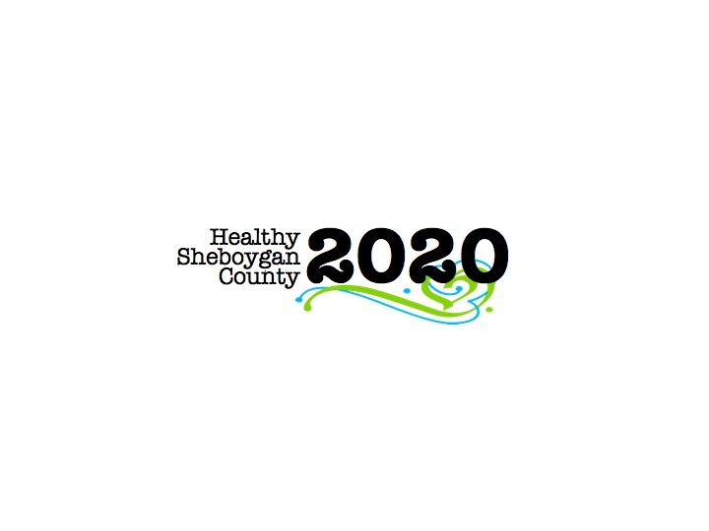
HSC 2020 Mental Health & Substance Abuse [MHSA]

Community Health Committee

HEROIN SUB-COMMITTEE MINUTES
DATE: | Wednesday, October 12th; 3:00pm-4:30pm | LOCATION: | Sheboygan Dept. of Health & Human Services Room 372
PRESIDING: | Libby Holte and Kurt Zempel
PRESENT: | Libby Holte, Kurt Zempel, Lindsay Rick, Regan Haulotte, Nancy TeSelle, Sue Thiel, Deb Schmidt, Mary Karls, Liz Campion, Mark Paluchniak, Liz Abler, Ellen Wells, Matt Spence, Kim Meller, Annette Selk, Jack Pawley, Paul Avery, Tim Tayloe, Jenny Vorpagel
ABSENT:
RECORDER: | Jenny Vorpagel
NEXT MEETING: | November 9th, 2016 3-4:30pm

PILLAR | TOPICS | DISCUSSION & DECISIONS  TAKE HOME TASKS
Welcome & Introductions | Welcome new members!  Libby briefly went over the HSC2020 and Heroin sub-committee structure.
PILLAR REPORTS:  Education/ Prevention Pillar | Plan Your Future Night at Plymouth High School is October 25th. There are different workshops and a keynote speaker. Liz Abler will be in the parent-to-parent group. There will also be a teen-to-teen group. Every parent who attends will be receiving a folder with resources from us. They may be able to use some grant money to also have materials at UW-Sheboygan about alcohol.  Deb and Libby are working with the Sheboygan Area School District to develop an assessment tool to see where the strengths and gaps are. In the end, this committee will partner with the schools to give them resources.  Libby will attend the school superintendents meeting in early 2017 to see if schools are using the Youth Risk Behavior Survey (YRBS) and if they can share that data with us. If we can get that data we can learn where our money is best spent, and see if our efforts are improving the community.  Requests for presentations: We are creating one presentation that anyone in our group can give to community members. A small group in prevention pillar are working on this presentation. Consistency in messaging is key.  Libby went to Sheboygan County Chamber workforce development event on September 29th. She got positive feedback on HSC2020.  Libby was on TV on October 5th! Betsy from the Chamber talked with Libby and Kristin Stearns regarding the “Someplace Better” initiative  The ThinkHaus presentation at the Kohler Art Center which included Sheriff Priebe went well.  Sue went to the health fair at St. Mark’s Lutheran Church. She let people know about the permanent drug drop off sites. Public Health Nurses also went to the Vollrath and Sargento health fairs giving out the same information.  There was a Community Pharmacy meeting was at the end of September; unfortunately it had poor turnout. Mary and Liz A. discussed how to revitalize that group since they are not actually a part of HSC2020. They are looking for someone at Advanced Pain Management to help facilitate the group.
Harm Reduction Pillar | --Medication disposal boxes (permanent). They are looking at who are their target audiences.  --Needle exchange—they have learned there are already two needle exchange programs in our community, so they are looking at how they can support them. (Labor of Love and AIDS resource center bus). Labor of Love says they exchange about 5,000 needles/month.  Kim Meller gave an update about a pharmacy that does needle exchange in Madison. He was aware of the AIDS resource center needle exchange in Sheboygan. He also said they sell NARCAN for $12-14, while it is sold for about $90 in Sheboygan County.  --Sharps containers—Currently in the exploration phase to see if we have a sharps problem in Sheboygan County, are they found in public places?  --Looking to collaborate with law enforcement, and they are determining what they want to measure.  Drug Take Back Day is October 22nd from 10-1pm at five locations in the county!  Make sure you do not put all the liquids in one box! Try to disperse them throughout all your boxes. We have two large banners. One will go to Plymouth. The group decided the other banner will go to Howards Grove.  The pillar meets the 2nd Monday of each month in room 348 of the HHS building from 10-11:30am—Anyone is welcome to attend! | Libby to talk to Tim about getting steaks for the sign in Plymouth. Mary working with station leaders to get the sharps containers back after 10/22.
Treatment Pillar | The pillar is planning another AODA networking event on November 4th at 8am in room 372 of the HHS building. The first networking event was three months ago and the people involved wanted it to be a regular event. These events help identify treatment gaps in the community.  Lindsay will be leaving HHS effective November 11th. We will miss you, Lindsay!!  We will be looking for a new treatment pillar captain. We are looking for someone to fill this role within the next month so Lindsay can communicate with the new captain before she leaves.  Pain 101—continuing education opportunity for providers- October 26th.  “Opioids in a new era” event on November 11th.  Kim reported that she saw Patrick Kennedy speak in Milwaukee about social welfare.  Drug Treatment court—5 candidates currently. They have signed a contract with a new provider. Men’s and women’s intensive outpatient and outpatient care. There are consequences if they do not attend classes. Ellen and Kurt gave a brief explanation of drug court. Candidates must be diagnosed with a severe addiction problem, and they must plead guilty to their charges, everything is done post-conviction.  November 16th at the full MHSA meeting at 9am in room 372, there will be a presentation on the drug treatment court. Anyone is welcome to attend.
Law Enforcement Pillar | Heroin with fentanyl (another opiate) is causing over doses in the community.  Kurt went to Lakeshore Safety Conference and the Kohler regional HR meeting.  There was a presentation at the Elks Club by the sheriff and others that Kim thought went well—about 50 people there.  Manitowoc County is having 2 presentations on marijuana called “Let’s be Blunt” on November 9th.
Workplace Pillar | The pillar met a week and a half ago. The survey was presented to the Chamber but they have not sent it out yet. Working with WI workforce development group and got a list of 2700 employers. The survey is an ask to organizations what plans and programs do you have in place. From there they will develop strategies to assist employers and what they need from us.  Kurt was wondering if any employers have post-accident drug testing. Jack and Paul from Kohler said some companies do that, but it’s difficult to determine what is an accident. Kohler currently does not have that in place.  Kohler update: They are hearing of drug use/selling going on at Kohler and still trying to figure out what to put in place.
Recovery Pillar | Robert could not make the meeting.  His update through email:  I have been in contact with a number of people who are interested in working on the recovery pillar. I have a few more that I am going to talk to at the state Narcotics Anonymous convention in Manitowoc this weekend. Right now I have five people are willing to be on the committee. After the convention this weekend I will send out a doodle calendar to figure out which days are going to work best for our pillar meetings. I will then contact you and let you know when we will be meeting and who is on the committee. **all pillars are open meetings. Anyone can join at any time**
Leadership Council Update | Libby explained the CHNA that the group of partners are currently working on. If you have any questions or comments on this, please contact Libby or Krisitn  Elizabeth.holte@sheboygancounty.com or kstearns@lakeshorechc.org
Roundtable | Families Anonymous group still meeting on at LCHC every Tuesday night. Kim will send electronic copies of brochures about the group.  SBIRT with Dr. Brown presentation, October 19th from 8-10am in 372  Libby will not be at the next meeting. She will be on maternity leave for 8 weeks. Please send any communication to HSC2020@sheboygancounty.com and Jenny Vorpagel will make sure it gets to the correct person.
Next Steps | Next meeting: Wednesday, November 9th 2016 HHS Room 372 3-4:30pm

