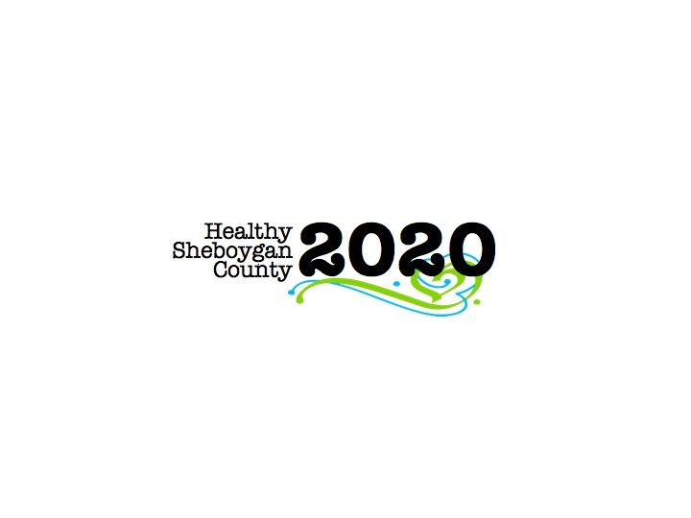
HSC 2020 Mental Health & Substance Abuse [MHSA]

Community Health Committee

HEROIN SUB-COMMITTEE MINUTES
DATE: | Wednesday, July 13th; 3:00pm-4:30pm | LOCATION: | Sheboygan Dept. of Health & Human Services Room 372
PRESIDING: | Libby Holte and Kurt Zempel
PRESENT: | Libby Holte, Kurt Zempel, Mark Paluchniak, Lindsay Rick, Robert Ingraham, Cindy Howley, Jack Pauley, Paul Avery, Annette Selk, Deb Schmidt, Becki Nue, Ashley Grant, Mary Karls, Pamela Kruger, Nick Larkin, Liz Campion, Jenny Vorpagel, Gail Schmeiser
ABSENT:
RECORDER: | Jenny Vorpagel
NEXT MEETING: | August 10th, 2016 3-4:30pm

PILLAR | DISCUSSION & DECISIONS  TAKE HOME TASKS
Welcome & Introductions | Roundtable introductions  Libby explained the recent restructure of the group. Each pillar meets outside of this meeting.
PILLAR REPORTS:  Education/ Prevention Pillar | The pillar met on June 30th with community partners including Plymouth schools and clinics. In elementary school, they learn about what makes them healthy. Middle school they discuss dangers of drugs and alcohol. In high school they cover opioids and drug abuse in 9th grade health class. AODA programs in the area are burdened and lacking staff. Most often people are put in jail and are not treated.  Plymouth is looking into adding something in their community and adding to school programs.  They are waiting to hear back from Plymouth schools/churches about a prevention event in the fall.  Libby met with the director of Love INC—They provide what they call “hand-ups” from the churches and they’d like to partner with HSC2020.  Kelly mentioned her Addiction Awareness Event, August 27th at Fountain Park 3-7:30pm—The event includes Rise Together, Stop Heroin Now, Just Listen, a recovery coach (Jesse), Tommy Casper (recovering addict), Rainbow Kids, Community Consultants, and Starting Point, and Pathways. I Love My Addict is more than just this event each year—they also do narcan trainings, films, weekly meetings, etc. Kelly is looking for help marketing the event, and for gift basket donations.
Harm Reduction Pillar | The pillar is finding out more about needle exchange. Needle exchange is needed, people are breaking into public sharps containers to find needles.  They are looking to expand narcan training to other places in the county, not just the city of Sheboygan.  Many of the goals are exploration of topics. Members of the pillar are looking into what other communities are doing that we could possibly bring to our community.  10/22/16 is permanent drug take-back day.  What does the recovery community look like in the county? They are looking for gaps.  Pillar is meeting again on August 8th from 10am in room 372 of the HHS building. Anyone is welcome to come.  Robert is trying to look into who is trained in the state as recovery coaches.  Its members voted down the 1907 Club as a recovery community. Robert is meeting about the possibility of creating a Wisconsin Recovery Community for Sheboygan County.  Drug court is not SMART recovery based. Instead, MRT is widely used for drug court.  Libby received a call saying the Sheboygan Falls police department would not take liquid meds for drop off like the hand out says. Please let her know if there are any other inconsistencies on the hand out.  The “Take Back the Night” event on August 2nd offered Healthy Sheboygan County 2020 to have an informational table at their event.
Treatment Pillar | The pillar met as a small group and began their meeting with education. Frank with Community Consultants says they hope to start the first MRT groups as of August at their location on New Jersey Avenue. They also hope to start social detox-2 beds by fall of fall 2016 and 4 beds for sober living by winter 2016.  Aurora is hoping to open 3 IOP groups (intensive outpatient programming) which is a 9 hour per week treatment. Partial hospitalization treatment is 30 hours per week.  Trauma Informed Care trainings scheduled for Fall 2016 and Spring 2017. Trauma Informed Care in the legal community is scheduled for Thursday, September 29th from 8-Noon at Blue Harbor in Sheboygan. They are hoping for 3 trainings in the next 6-9 months.  The group also reviewed the CHIP and set priorities. They are planning a networking event for treatment providers on the morning of Thursday, August 25th 2016 breakfast event.  They also hope to start planning another CEU event to increase quality of care in the area for Spring 2017.  September is national recovery month. They are working on planning an event during September to show solidarity.  This pillar does not have a regular meeting date. It is be easier for them to communicate via email and meet when needed.
Law Enforcement Pillar | -Drug endangered children protocol is being finished.  On June 23^{rd,} we had a prescriber roundtable with 84 people in attendance. We are hoping to do another event in the fall with even more providers present.  Only 15-20% of prescribers use prescription drug monitoring program.  Resource guide—Kurt and Libby meeting tomorrow with MHA about the resource guide for MHSA services. The guide is on the MHA website and linked to MHA from HSC2020 website. http://www.mhasheboygan.org/assets/Uploads/pdfs/Resource-Card-1.2015.pdf  Substance abuse could have a stand-alone guide to be given out from law enforcement and at the jails.  The group agreed that a Sheboygan County resources smart phone App would be wonderful. So far no one has come forward knowing how to move forward with the idea.
Workplace Pillar | They are working to develop a survey for local businesses for us to better understand their drug policies and if they discriminate against drug users. AHEC interns will work on the survey.  Cindy-put together a list from their company and share that with other companies. What kind of support does the company provide?  SCAN is working with companies on Well County initiative—we could also communicate with these companies about drugs/addiction.  Acuity grants were given to the Sheboygan Police Department. If we need funding from this grant, we can use it for our purposes.
National Recovery Month | Tabled.
Next Steps | Each pillar group to have meetings outside of the heroin sub-committee meeting.  Please send any events you have to HSC2020@SheboyganCounty.com. We are creating an all MHSA events calendar that we can send out.

