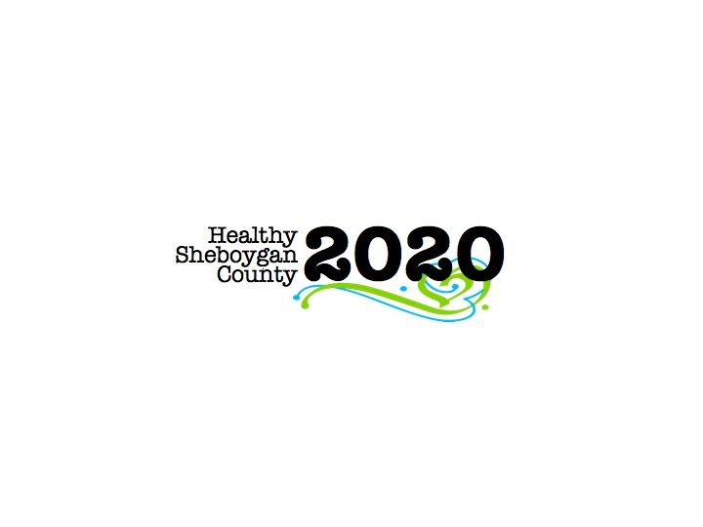
HSC 2020 Mental Health & Substance Abuse [MHSA]

Community Health Committee

HEROIN SUB-COMMITTEE MINUTES
DATE: | Wednesday, January 11th 2017; 3:00pm-4:30pm | LOCATION: | Sheboygan Dept. of Health & Human Services Room 372
PRESIDING: | Libby Holte and Kurt Zempel
PRESENT: | Jenny Vorpagel, Paul Avery, Pamela Krueger, Ellen Wells, Mary Paluchniak, Stephanie Weeden, Deb Schmidt, Michelle Kleppin, Sue Thiel, Liz Campion, Annette Selk, Kim Meller, Kurt Zempel, Libby Holte, Nick Larkin
ABSENT:
RECORDER: | Jenny Vorpagel
NEXT MEETING: | February 8th, 2017 3-4:30pm

PILLAR | TOPICS | DISCUSSION & DECISIONS  TAKE HOME TASKS
Welcome & Introductions | Welcome back, Libby!
PILLAR REPORTS:  Education/ Prevention Pillar | Pillar did not meet in December. Next meeting is January 24th 1-2pm in room 218 of the HHS building.  Libby and Deb are working on collaborating with the school districts. They will be asking superintendents to give out a short survey about where they are at/gaps and the youth risk behavior survey. SASD has an AODA supervisor but it is only one person and it is 10% of his job. Libby and Deb are meeting with the SASD AODA supervisor (Regan). Sue asked them to ask Regan about the good behavior game that Kurt mentioned at a previous meeting.  Annette and Jessica are working on updating the presentation PowerPoint. They are also working on a log of where it is being presented. It is not yet ready to be presented to “train the trainer”. Discussion took place regarding the best time to have a training on the presentation. Sue suggested this be put on the agenda of the full MHSA meeting on January 18th.  Alliance for Wisconsin Youth is looking to do training for SBIRT in schools. SBIRT is applying for some money, they will know if they receive any money by the end of March/beginning of April. That way the SBIRT trainings would not be using as much of the “Acuity” money that could be used for other things.  Misty and Libby will be doing a heroin presentation at the Random Lake library on January 26th at 6pm. Kurt will also be presenting at the Evangelical church on 15th street that same night. | The presentation training will be added to the MHSA full committee meeting agenda in case anyone outside of the heroin group is also interested in attending.
Harm Reduction Pillar | The pillar has reached out to funeral homes. Mary will be speaking in front of funeral director group on February 7th and is looking for someone in law enforcement to go with her. Location not yet known.  Community sharps containers—struggling to find out if it is an actual need in our community.  The Spring drug take back day is set for Saturday, April 29^{th.} Group discussed what could be done better at the next take back day. Are there different locations in each city/town that would work better? There are concerns regarding adding more locations because in the fall we struggled to staff the 5 locations.
Treatment Pillar | A meeting took place yesterday about where the treatment pillar is headed now that Lindsay is gone. Nick as agreed to plan the next networking event in the interim. He is hoping to recruit more people for the pillar at the networking event, including a possible treatment pillar chair.  Discussion took place regarding “Medical detailing” being adopted for prevention purposes.
Law Enforcement Pillar | No new updates.
Workplace Pillar | Jenny will schedule a meeting for the last week of January. Modeling the “drug free workplace”, Jenny has an intern working with Ellen’s database for more HR contacts.  The President of Step Industries in Neenah is willing to meet with the pillar to share with us what they do there.
Recovery Pillar | Families Anonymous is now meeting the 1st and 3rd Tuesday of each month at LCHC at 7pm. Anyone who wants more information can contact Stan Kayman at 920-226-1415
Leadership Council Update | The structure of the HSC2020 committees may change along with the Community Health Needs Assessment. They will be looking into the possibility of addressing other substances.  The Stigma committee looking for volunteers for the resource fair. Please email  Jessica@ MHASheboygan.org if you are interested. | Each pillar to come up with 1-3 concrete things they want to get done in 2017.
Next Steps

