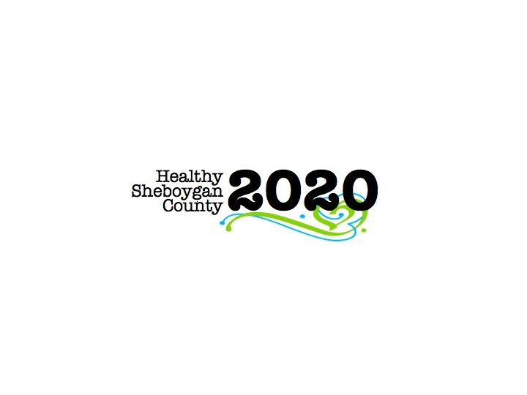
HSC 2020 Mental Health & Substance Abuse [MHSA]

Community Health Committee

HEROIN SUB-COMMITTEE MINUTES
DATE: | Wednesday, April 12th 2017; 3:00pm-4:30pm | LOCATION: | Sheboygan Dept. of Health & Human Services Room 372
PRESIDING: | Libby Holte and Kurt Zempel
PRESENT: | Jenny Vorpagel, Kim Meller, Libby Holte, Kurt Zempel, John Nonweiler, Sue Thiel, Mary Paluchniak, Liz Campion, Vicky Schneider, Mary Karls, Annette Selk, Nick Larkin, Steph Preder
ABSENT:
RECORDER: | Jenny Vorpagel
NEXT MEETING: | May 10th, 2017 3-4:30pm

PILLAR | TOPICS | DISCUSSION & DECISIONS  TAKE HOME TASKS
Welcome & Introductions
Drug Take Back Day  APRIL 29th 2017 | Distribute Materials/Give Instructions 10am-1pm at the following locations and leads  - St Nicks-Mary  - Random Lake-Ellen Wells  - Plymouth-Libby Holte  - Oostburg-Sue Thiel  - Howards Grove-Kim Meller  It works well if one person is assigned to ask questions for the survey. We are looking closer at marketing. If someone said they saw it in a newspaper, please find out which one. Also ask if the banner signs are helpful.  There are ziplock bags for liquids, please disburse liquids throughout all the boxes. Also label the box with your location and “1 of __, 2 of ___, etc.”  The law enforcement officer will take the sharps containers.  Inhalers and epi-pens should be put together in a separate box.  Libby’s cell phone number is on the information packet if any questions come up the day of. | Mary will clarify whether the inhaler and epi-pen box should be included in the “1 of __”
PILLAR REPORTS:  Education/ Prevention Pillar | Train the Presenter—Opioid Presentation Dates:  April 20th 2:30-4:30pm and April 21st 8-10am both in room 413. RSVP to HSC2020@sheboygancounty.com if interested in attending.  Libby attended the school administrators meeting about administering the YRBS survey. They are interested in partnering with us in the future, but it is too late for this year. They are interested in holding focus groups with school administrators. Libby will keep in contact with them for next steps.  Vicky worked on cover letters that are going to realtors, dentist and vet clinics and passed it on to the harm prevention pillar.  Advanced Pain Management collaborating with us for presentation on May 23rd from 5:30-8pm at the Black Pig. A save the date will be going out soon.  Aurora clinic must scan a valid ID of anyone picking up narcotic medications.  Next meeting is April 25th from 1-2pm in HHS room 218.  Kurt and Libby did a presentation at UW-Sheboygan on Monday night and it went well.
Harm Reduction Pillar | Working on getting permanent drug drop boxes info out.  Working on sharps: legal use, how to dispose of, etc.  Got cover letters from prevention pillar and working on getting those out to respective areas of the community.
Treatment Pillar | March 30th networking event was well attended—30 people and 18 organizations. Every level of care was represented. New initiatives—opioid outpatient detox. Addicted parents in CPS are given priority right now. New issue: meth is making a comeback in the county. All agencies were told about the drug take back day and permanent drug disposal sites. Information about Labor of Love was given out. #1 gap in treatment is adolescents treatment for AODA issues.  Lots of good feedback and they would like it to be a quarterly event.  Pathways will be starting an opioid detox program.
Law Enforcement Pillar | Prescription drug monitoring program—requiring all prescribers and pharmacies to check the PDMP with any new opioid prescriptions. Another flag is if you drive more than 60 miles to see a provider.  Last week Kurt went to NYPD about responding to opioids: 1.6 million pounds of unused medication was collected last year at drug take back days. 5,000 sites in the US. About 10% is opioids. There is a video available called Chasing the Dragon that is appropriate for the school setting. They are adding the science of addiction to middle school kids for the STEM project.  43% purity of one Sheboygan heroin sample from last year was tested in MKE.  Nick reported that all police officers are now carrying narcan.  26 narcan saves in 2016 by rescue workers. Dane County had about 100, and Louisville, KY had 700 narcan saves last year.  Kurt mentioned again that he wants to implement in Sheboygan County people being able to hand over their illegal drugs to law enforcement if they need recovery help, with no legal implications. People are getting placed into treatment at a higher rate by going to law enforcement than a health care provider.  Group discussed whether it would be a boundary to make the case that most people do not get well in recovery on their first try.
Workplace Pillar | Kurt talked to Kohler security staff so they can make informed decisions about employees with drug abuse or coming to work under the influence. They created a handbook that could be used as a template for other companies.  Continuing with Step industries.
Recovery Pillar | Meeting tomorrow about recovery coaches.  WIRCO is working on getting started up. They are having a bray fry May 6th from 9-2:30 at Miesfelds.  Families Anonymous group is now having active people coming to meetings.  Kim was asked to speak at opioid taskforce by Rep. Nygren.
Leadership Council Update | Tabled
Next Steps | The 3rd Annual Mental Health and AODA Resource Fair is May 2nd from 4-7pm at St. Dominic Parish Activity Center

