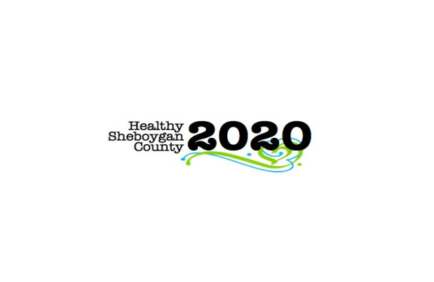
HSC 2020 Leadership Council Meeting
Minutes

Mission: To improve the health of the people of Sheboygan County leading to a community with
“Everyone Living Better, Longer”

DATE: | Monday, February 27th 3:00 to 4:30 p.m. |  |  |  | AT: |  | Health and Human Services, 1011 North 8th Street, Sheboygan, Room 372
PRESIDING: |  | Kristin Stearns and Libby Holte |  | PRESENT: |  | Jean Pittner, Amy Betke, Jane Brill, Libby Holte, Kristin Stearns, Mary Paluchinak, Karlyn Raddatz, Shannon Wanek, Tom E, Jenny Vorpagel, Ann Bachrach
 |  |  |  | EXCUSED: |  | Tom Malmstadt, Jane Jensen, Shelby Kuhn, Kari Keller, Kate Bear
RECORDER: |  | Jenny Vorpagel
NEXT MEETING: |  |  | March 27th, 2017 3:00-4:30 p.m. | INVITED GUESTS: |  | Christa Wilson

ITEM | DISCUSSION/CONCLUSION/RECOMMENDATIONS | ACTIONS
Call to Order, Welcome and Introductions | Call to order at 3:06pm
Additions to agenda | No additions
Correspondence | No updates
Secretary’s Report - Angela  See link to minutes -- | No changes to the minutes http://www.healthysheboygancounty.org/assets/Uploads/Steering-Committee/Steering-Committee-Minutes/Minutes-1-23-2017.pdf | Minutes will continue to be on website and not emailed
Treasurer’s Report/Fiscal Agent Update | Process for fund request approval. No monetary changes since last meeting. LCHC financial director to reach out to Shannon/Deb Hoffman to begin as fiscal agent. Make out checks to Lakeshore Community Healthcare. In the memo line include HSC2020 and committee it is for. The form as it stands does not need to be approved by the leadership council. It needs two signatures, Shannon’s and Libby’s (never Kristin). This process to remain in place. Libby to use best judgement whether to take it to the full leadership council. Request for funds—Shannon-Libby-Kristin | Kristin will get monthly report and ensure Shannon gets a copy.  Jenny to add form to the leadership council page of HSC202 website.
Well County Update | Amy updated the group on the status of the Well County initiative. There was an event at Sargento last week. 2 WELCOA staff presented about the process. Event was well received.  Next steps—April 19th at Sargento (all day) Wellness University training-- when companies can network and get hands on experience. Event goes into specific detail on each step to become a wellness workplace. WELCOA does the training. The companies are divided into 3 groups each with a local leader to help guide them through the process.  Reviewed 5 year budget. Sheboygan YMCA holds their funds. Received $1,000 check from Bemis.  Annual celebration in December in the planning process. | Informational
CHNA Update/Timeline | Timeline for CHNA/CHIP—  The group went through the CHIP/CHNA timeline  -Key informant interviews to be completed by March 1st, Community survey has been completed. The survey takers called from a 414 area code. CHNA group to plan call to action event scheduled for a date in the 2nd half of September.  -CHNA will be completed in June and will be shared with all committees  -Last quarter of 2017—share call to action results with attendees  -March-June 2017-Leadership council to redefine expectations, provide format for annual report, develop process/work plan templates for committees to provide updates. Discussion about inviting key informants to join leadership council and describe to them what we would ask of them if they joined  -Leadership council-May-July analyze and ID priority areas from the completed CHA  -July-Oct—CHC—Start intervention planning education “What are we doing” (action center flow chart) and leadership council expectations of committees.  -Group discussed educating leadership and chairs of committees first to fill the gaps of summer vacations.  -CHC-introduce work plan and provide outcomes/logic model training with chairs and committees (Oct-Dec)  -CHC-Jan-Feb 2018—write work plan for CHIP (leadership at same time provide input and feedback on chosen interventions from CHC’s.  -March 2018—CHIP finalized.  -April-May 2018—Leadership council and CHC’s share CHIP with community partners  -Discussion took place on the possibility of committees needing to change rather than the existing committees remaining as is. We don’t want to get rid of the work that we’ve already built, but also don’t want what we already built trump what the new data suggests. Kristin explained how Manitowoc County had a meeting strictly about one data point.  Tom M, Jane J, and Libby got together to discuss the outcomes training to measure success. We should teach how to measure and what to measure. | Kristin and Libby will discuss what needs to be done for Leadership Council on the timeline and will have a call to action update for the March meeting.
Updates from CHC’s  - SCAN  - Mental Health  - SBIRT  - Heroin  - Stigma | SBIRT—report out on meeting with school administrators  -SBIRT was awarded AWY grant ($2,000) up front and $900 after.  -Kiel and New Holstein SD’s also interested in coming to Summer training session.  -Kristin attended meeting with School Administrators—LCHC sent to Tom a list of places to make referrals in the county. She reviewed the SBIRT process, it is mostly motivational interviewing and brief interventions.  They have 2 big concerns:  -They aren’t confident that they are getting the help they need once they are out of their hands. (coornidation of care)  -Extreme cases (1% that takes up most of resources) They feel they’re not getting the suppor they need from other organizations.  -Discussion took place that schools should communicate their needs to these organizations and they would be happy to meet with them and help them out.  - Grant opportunity through federal government-Prevention of Opoid misuse in women $100,000 ceiling. Can be non-profit or government agency. SBIRT is one of the uses.  -UW-Madison grant that Shelby is aware of—Kristin will send it out to Libby and Shelby.  Stigma-Working hard to get resource guides out to community, working on QPR  Heroin-Pillar leaders/co-chairs met on how to best utilize resources. Each pillar to come up with key goals. Drug Take Back Day is April 29th, the committee will soon be asking for volunteers.  SCAN-Food Drive toolkit being worked on now for healthier food donations. Final toolkit to be finished in March. Jackson Elementary will be doing a walk/ride bike to school day on May 9th. SASD received PEP grant. Harvest of the Month goes on the HSC2020 website each month, also goes out to all WIC clients. Double your Bucks (winter version) Much more EBT is used on double your bucks days. Looking into WIC clients also getting to double their bucks. | Kristin to reach out to Tom M. and Law Enforcement
Check Out/Agency Sharing - All | LCHC Medical Behavorial Health Wing to open next Monday (3/6/17)
Next Meeting  Agenda items | March 27th, 2016 3:00-4:30 p.m. room 372
Adjournment | Meeting adjourned at 4:33pm

